NAME : Zahra Juzer
ROLL NO. : SP26-BSAI-0029
PROGRAM/SEMSTER : BS in Artificial Intelligence/ 1st Semester
ASSIGNMENT NAME : Computer programming Lab

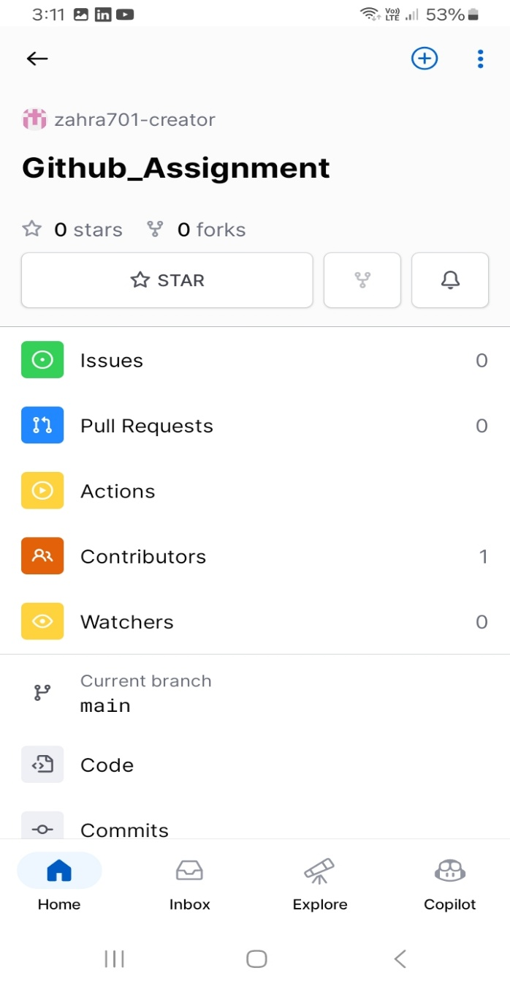
REPOSITORY LINK: https://github.com/zahra701-creator/Github_Assignment

